 | Abdi İpekçi Caddesi Kaşıkçıoğlu Apt. No:42 D:2 34365 Nişantaşı İstanbul  www.artxist.com  info@artxist.com  T. +90 212 291 77 84 F. +90 212 343 69 35 | PRESS RELEASE

INTERIOR & EXTERIOR

Nuri Kuzucan, who has garnered a solid following in the art-world with works firmly grounded in the urban landscape and structure, is expected to thrill his audience with his fifth solo exhibition
‘Interior & Exterior’ opening on November 17th, 2011 at x-ist.

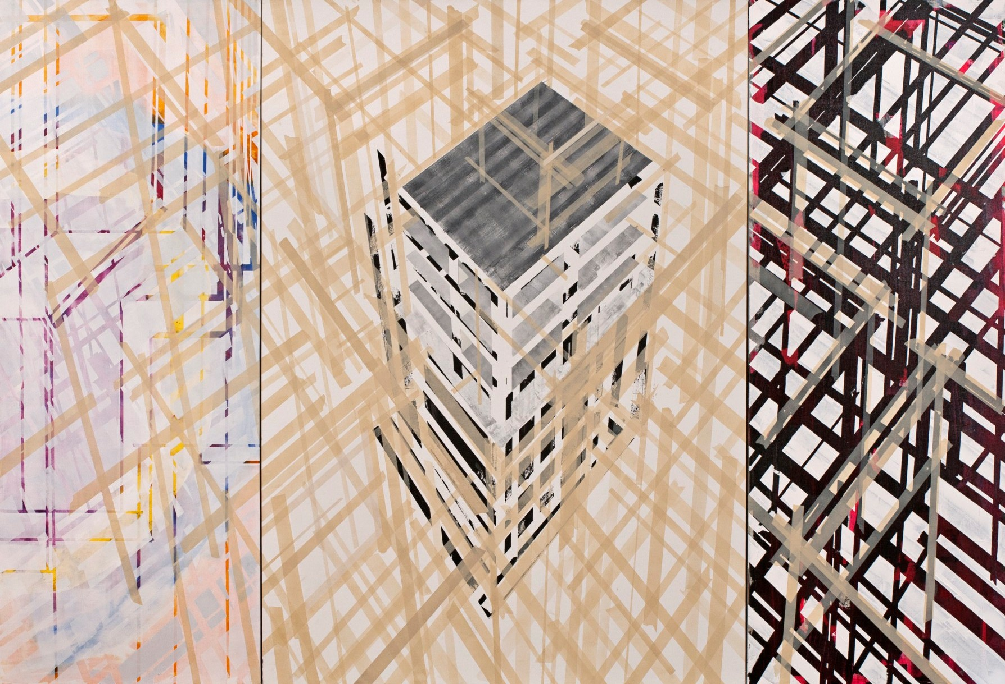

Nuri Kuzucan, Triptych Construction, acrylic on canvas, 200 x 290 cm, 2011

Kuzucan’s fifth solo show, Interior & Exterior opens the door for the viewer to explore the reflections & shadows of the city. In the exhibit, the audience should be prepared to find themselves suddenly as witnesses to the investigation of the hidden story behind landscapes and the power of the city. At the same time, the artist turns visitors into observers and offers a unique experience which is visually engaging through multi-faceted mental associations in his works. The exhibition, shifting from a detailed focused gaze, to a micro/macro perspective questing between the sum and its part, takes an infinite & fluid shape like the dynamics of fluid motion of the city and urban architecture.

In this exhibition, the works, in which the audience becomes the subject through the questing layers and the reflections of interior & exterior spaces, objects and the details, diverge from urban architecture. Kuzucan creates a deeper connection between the viewer and the urban landscapes as he pauses and simplifies the chaotic world we live in and invites the audience from the exterior into the interior. The exhibit can be seen till December 17, 2011 at x-ist.

NURİ KUZUCAN Zara, 1971

Kuzucan studied at the Mimar Sinan Social Sciences Institute after he graduated from Mimar Sinan Fine Arts School. He had four solo shows at x-ist Open Place (2004), Traffic (2006), Are You Happy? (2008) and Plan (2010). The artist participated in Contemporary Istanbul 07, 08, 09 and 10, artFair06 Cologne, SCOPE Basel 2010 & 2011 and 2011, ART HK’11 (Hong Kong International Art Fair) and Art Dubai 2011 fairs.

Ansen, Kayseri, 1978

Ansen studied painting at the Mimar Sinan Faculty of Fine Arts. He has had four solo exhibitions at x-ist between 2004 and 2009, x-ist-ence, Resistance, Menace, and The Trace. He participated in The Contemporary Istanbul 06, 07, 08 and 10, artfair06 Cologne, CIGE 08 – China International Gallery

